|  |  |  |  |  |
| --- | --- | --- | --- | --- |
|  | | | | |
|  |  |  | |  |
| Project idea  naan mudhalvan  Proj_203625_  953621104060@ritrjpm.ac.in  953621104009@ritrjpm.ac.in  953621104018@ritrjpm.ac.in  953621104048@ritrjpm.ac.in  953621104045@ritrjpm.ac.in  953621104051@ritrjpm.ac.in  953621104012@ritrjpm.ac.in | | |
|  | |  |

***Diabetes Prediction Chatbot Design***

**Category:** Machine Learning

**Programming Language:** Python

**Tools & Libraries:** ChatterBot, scikit-learn, Tensor-flow, numpy, pandas, NLTK (Natural Language Toolkit)

**Front end:** HTML, CSS, Java script, Python Tkinter

**Data set Link:** <https://www.kaggle.com/datasets/grafstor/simple-dialogs-for-chatbot>

**Introduction**

Chatbots in Python have gained widespread acceptance across various industries, revolutionizing interactions with users. These intelligent systems, capable of imitating natural human language, find applications in digital commerce, healthcare, and beyond. This guide provides a detailed walkthrough on creating a Python chatbot using the ChatterBot library.

**Problem Definition**

The objective is to build an AI-powered diabetes prediction system that utilizes machine learning algorithms to analyze medical data and predict the likelihood of an individual developing diabetes. The system aims to provide early risk assessment and personalized preventive measures, enabling individuals to take proactive actions to manage their health.

**Design Thinking**

**Functionality**

The chatbot's core functionalities include:

1. **Risk Assessment:**
   * Analyze medical data to assess the risk of developing diabetes.
2. **Guidance and Information:**
   * Provide guidance on diabetes prevention strategies and healthy lifestyle choices.
3. **User Interaction:**
   * Engage users in natural and informative conversations about diabetes-related queries.
4. **Resource Direction:**
   * Direct users to relevant resources for additional information or professional help.

**User Interface**

1. **Integration Platform:**
   * The chatbot will be integrated into a user-friendly website to ensure accessibility.
2. **User Input:**
   * Design an intuitive interface for users to input relevant medical information.
3. **Output Display:**
   * Display risk assessment results and personalized recommendations in a clear and understandable format.

**Natural Language Processing (NLP)**

1. **Intent Recognition:**
   * Implement NLP techniques to recognize user intents related to health queries.
2. **Entity Extraction:**
   * Extract relevant entities from user input, such as age, family medical history, and lifestyle habits.
3. **Conversational Flow:**
   * Design a natural conversational flow to engage users and gather necessary information.

**Responses**

1. **Accurate Answers:**
   * Craft responses that provide accurate information based on the analyzed medical data.
2. **Suggestions:**
   * Offer personalized suggestions for lifestyle changes, diet modifications, and exercise routines.
3. **Assistance:**
   * Provide assistance in understanding medical terms and interpreting risk assessment results.

**Integration**

1. **Website Integration:**
   * Integrate the chatbot seamlessly into the website, ensuring a smooth and responsive user experience.
2. **Data Security:**
   * Implement robust security measures to protect user data and maintain privacy.
3. **API Integration (Optional):**
   * Explore options for integrating the chatbot with external health databases or APIs for additional insights.

**Testing and Improvement**

1. **User Testing:**
   * Conduct extensive user testing to identify potential issues and gather feedback.
2. **Performance Metrics:**
   * Define metrics to evaluate the chatbot's performance, including accuracy of predictions and user satisfaction.
3. **Continuous Improvement:**
   * Regularly update the chatbot based on user feedback, changing medical guidelines, and advancements in machine learning algorithms.

**Deployment**

Deploy the chatbot on a suitable platform, such as a website or messaging app, to enable user interaction.

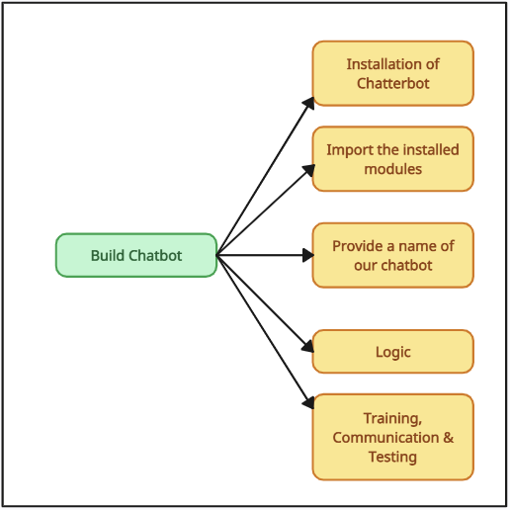**Building**

**Use-Case Diagram:**

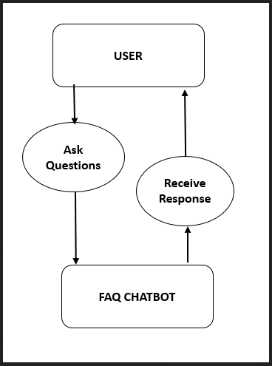

**How Does the Chatbot Python Work?**

**Rule-Based Approach**

Chatbot Python follows predefined rules to comprehend and respond to user queries. Developers manually program these rules.

**Self-Learning Approach**

Chatbots employing machine learning to enhance conversational skills over time. Two categories include:

* **Retrieval-Based Models:** Retrieve predefined responses from a knowledge base.
* **Generative Models:** Create responses from scratch using advanced models.

**What is ChatterBot Library?**

ChatterBot is a Python library simplifying chatbot creation, managing natural language processing challenges. Key features include language independence and TF-IDF-based response generation.

**How Does ChatterBot Library Work?**

ChatterBot combines a language database with an AI system, using TF-IDF and cosine similarity to match user input to proper responses.

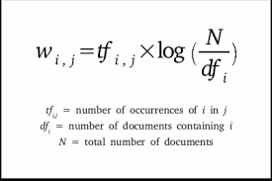

**How To Install ChatterBot In Python**

1. Launch a terminal or command prompt and ensure Python is configured.
2. Use the command "pip install chatterbot" to install ChatterBot and its dependencies.
3. Import ChatterBot in your Python script or interactive environment to start building your chatbot.

**Conclusion:**

In conclusion, the development of an AI-powered diabetes prediction chatbot involves a stack of versatile technologies. Leveraging Python for its rich ecosystem, machine learning libraries like Scikit-learn for predictive modeling, and NLP frameworks such as NLTK contribute to the chatbot's analytical capabilities. ChatterBot simplifies the implementation of conversational logic, while Flask or Django serves as a reliable backend framework. For user interaction, HTML, CSS, and JavaScript or Python Tkinter can be employed. The versatility of these technologies empowers the chatbot to provide personalized health insights and guidance effectively.